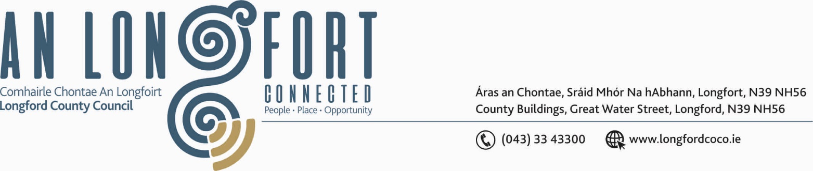

BALLYMAHON MUNICIPAL DISTRICT

1st October 2019.

To: Each Member of Ballymahon Municipal District.

A Chomhairleoir,

You are requested to attend Meeting of Ballymahon Municipal District to be held in the Council Chamber, Aras an Chontae, Longford on Thursday, 24th October 2019 at
4.00 p.m. to consider the 2020 General Municipal Allocation

Mise le meas,
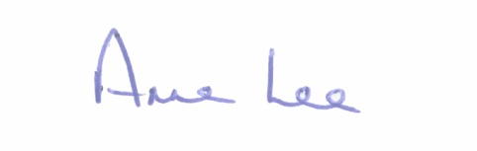

________________
Anne Lee,
Meetings Administrator.



